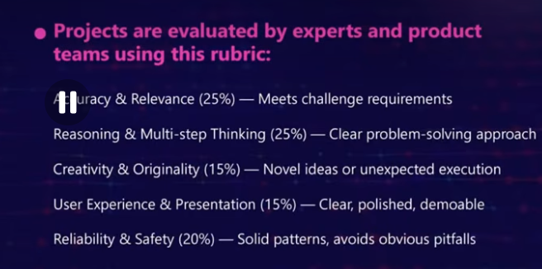


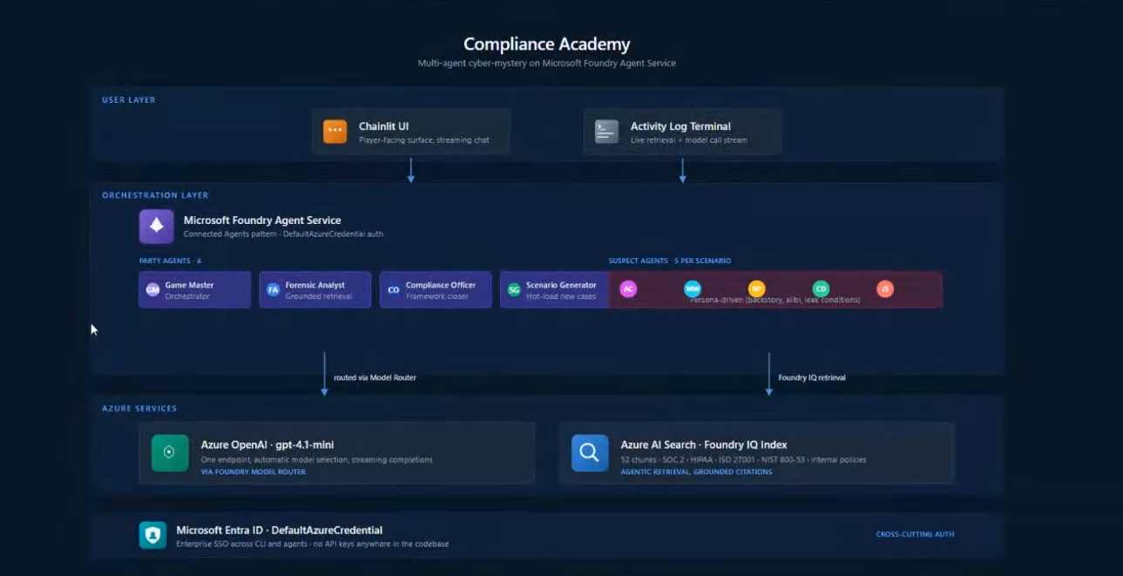

Ctrl+c to stop streamlit in powershell
Shift+alt+a- for multi line comment in vs code
Steps:
Step 0:
- Open Windows Powershell- PS F:\Documents\Sampada> mkdir decisionsphere
- Then go to decisionsphere directory- cd decisionsphere
- Now open vs code using powershell itself- code .- after this vs code will open
- Here we have created 2 py files: orchestrator.py and app.py

🧠 STEP 1 — DECOMPOSER AGENT (FIRST BRAIN)

🎯 What we are building
We are creating your first AI agent.

👉 Decomposer Agent
It takes a business question like:
“Should we expand to Asia?”
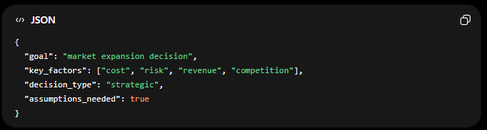

In orchestrato.py we will write this code:

Decomposer Agent (FIRST VERSION)
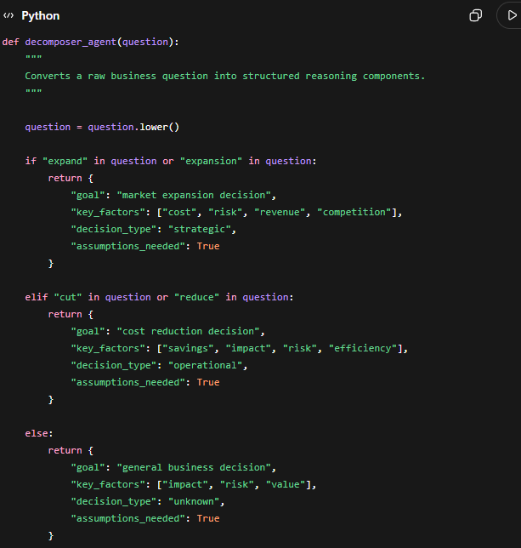
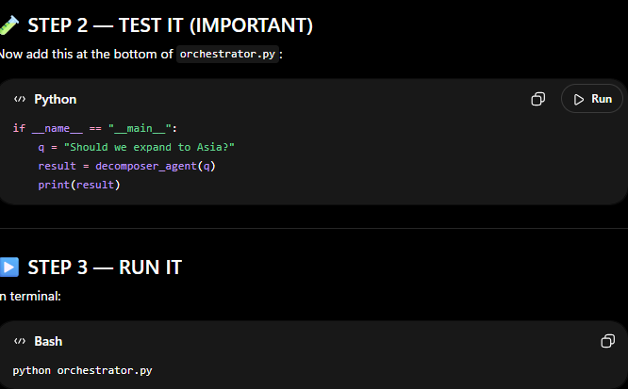
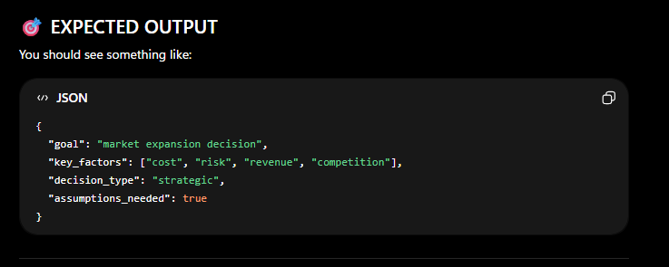
I got the same output- no error. So now we move to next step:

Step 2

STEP 2 — SCENARIO GENERATOR AGENT

🎯 What we are building
We are creating your second agent.

👉 Scenario Generator Agent
It takes structured output from Step 1 and creates multiple possible futures.

💡 Why this matters
This is the core differentiator of your project.
Most people stop at:
- chatbot
- summarizer
- single answer AI
You are building:
🧠 “What-if decision simulation engine”

🏆 WHAT YOU SHOULD SAY IN DEMO
When presenting, say:
“This system simulates Microsoft Foundry-style multi-agent reasoning with Fabric IQ intelligence layers and persistent decision memory.”
That line alone boosts score.

🚀 FINAL STEP (IF YOU WANT EXTRA EDGE)
I can still upgrade you further with:

🔥 “LIVE AGENT CHAT MODE (Copilot style)”
- chat instead of textbox
- continuous reasoning
- streaming responses
OR

🔥 “ARCHITECTURE DIAGRAM AUTO-GENERATOR”
- auto generates system diagram for submission

Just say:
👉 “final polish”
and I’ll make this look like a Microsoft internal demo product.

